Wind Flow over Complex Terrain: Application of Linear and CFD Models.

Pep Moreno¹, Arne R. Gravdahl², & Manel Romero¹
¹ Ecotècnia SCCL. Amistat 23. 08005 Barcelona, SPAIN. +34 93 225 76 00 / 221 09 39. pmoreno@ecotecnia.com
² VECTOR AS. Industrigaten 9. 3117 Toensberg, NORWAY. +47 33 38 18 00 / 08. vector@vector.no

Abstract

The paper describes a comparison of the plain application of linear model WAsP, a weighted combination of WAsP models and the CFD model WindSim on some examples on complex terrain performed as a collaboration between Ecotècnia and VECTOR. Some instrumented measurement campaigns are used as a test for the models. The encouraging results of this applications adviced Ecotècnia to incorporate the application of WindSim in the standard study procedure as a complementary way to the usual linear models.

Background

Many windy places around the world are located in mountainous regions. Within these regions, well exposed areas can easily be surrounded by much less windy spots located only few tenths of meters apart each other. Planning wind farm on those scenarios is a much more challenging and risky task than setting farms on flat terrain.

Ecotècnia has been designing and constructing wind farms on complex terrain since 1981. Approximately 80% of our projects are located in mountainous areas. To deal with such scenarios, our standard methodology incorporates a set-up of an uncommonly high number of measurement masts in the field.

Nevertheless, even many masts are never enough and wind flow modelling is always a need. Current commercial flow modelling software are based on the linearization of the (Navier-Stokes) flow equations. To perform such simplification the slopes of the terrain under the flow are assumed to be small. This is almost never the case on complex terrain. Thus, linear models are many times applied on scenarios away from their design conditions. This is, anyway, a common practice due to the advantages of the models and a lack of alternatives.

An emerging alternative to the misapplication of linear models is CFD (Computational Fluid Dynamics), product of an active research effort made since mid 80s to avoid the need of linearizing the flow equations and numerically solve the complete problem. This is what package WindSim, that VECTOR AS keeps developing since 1997, does. After its extensive use in the generation of the “Norwegian Wind Atlas” (1) this software has successfully been used in several blind-tests, the first of which was performed in collaboration with Ecotècnia, since mid 2000.

Objectives
A comparison of the plain application of linear model WAsP, a weighted combination of WAsP models and the CFD model WindSim on several cases of complex terrain is presented.

Methodology

MCP

At Ecotècnia we are very concern of the, sometimes large, distance between wind flow modelling and reality. This problem is specially critical over complex terrain where we design most of our projects. Our company have traditionally focused on complex terrain wind farms and even some of our newest megawatt turbines are specially suitable for installation, maintenance and operation on this type of scenarios (2).

The additional financial risk that the high uncertainty of the wind resource over complex terrain implies has, in the past, been largely compensated by the strong winds of many of these areas. This is (and will become) gradually less and less true as the better places are being occupied or discarded for connection-to-the-grid, construction or environmental reasons. Many less-windy places are already under study and their accurate determination of the wind-field becomes more important.

Traditionally our approach to this problem has been the set-up of a large number of measurements masts. The number of masts is “large” when compared with the number of turbines to be installed (table 1).

Nevertheless, not all masts of a certain project are running at the same time. Such procedure would be too expensive. Instead, some masts are alternative moved to different locations according to what indicated by previous measurements and preliminary wind flow modelling runs. One of the masts is, anyway, kept always there as a reference and to compare afterwards with long-term nearby data (figure 1).

Once the measurement campaign is finished, the different measured periods are homogenised to the longest one (the reference mast’s one) by means of a Ecotècnia in-house methodology validated by the british institute CCLRC (3).

Such method is based on a both wind speed-and-direction correlation of the simultaneous time series at the reference mast and the auxiliary ones. Its reliability has been proved in an ambitious JOULE project (4) where it shown the best performance in its category. The inclusion of both variables in the algorithms is necessary due to the sometimes strong direction-shifts experienced by wind over complex terrain.

Project ID | Masts | Turbines | Masts/Turbine
041 | 15 | 91 | 0.16
017 | 15 | 66 | 0.23
018 | 14 | 81 | 0.17
192 | 12 | 133 | 0.09
057 | 9 | 85 | 0.11
019 | 9 | 14 | 0.64
103 | 9 | 17 | 0.52
459 | 8 | 80 | 0.10
022 | 8 | 27 | 0.30
162 | 6 | 28 | 0.21
195 | 6 | 30 | 0.20
046 | 6 | 33 | 0.18
227 | 6 | 53 | 0.11
059 | 5 | 42 | 0.12
600 | 5 | 31 | 0.16
060 | 5 | 39 | 0.13
579 | 5 | 27 | 0.19

Table 1 Top-17 Ecotècnia projects in number of deployed met. masts

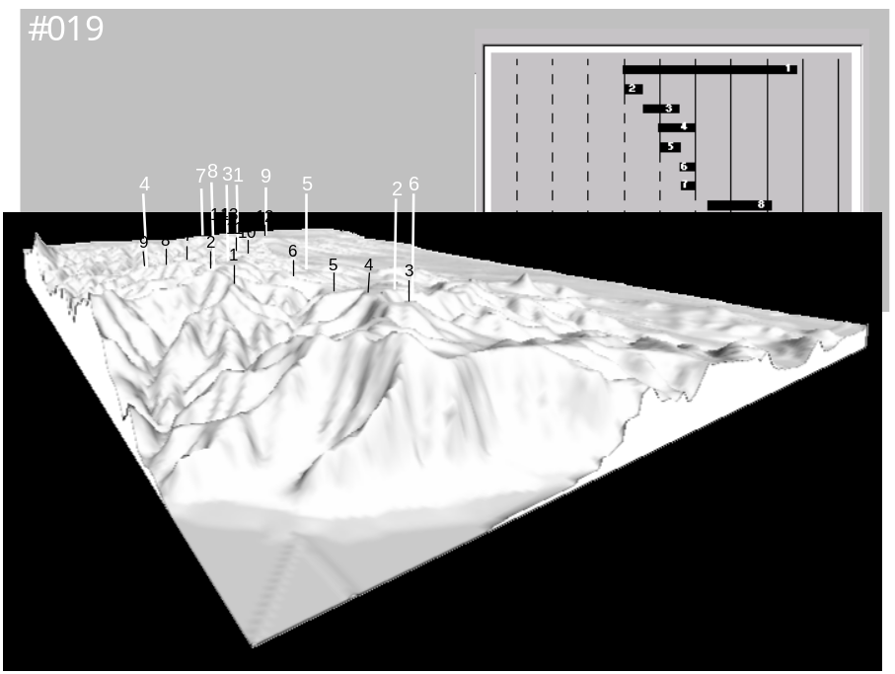

Figure 1 Project #019. 5 masts (moved along 9 locations) to locate 14 turbines on a 5x2km² region.

Self and Cross-Checking

Even a set of correlated measurements as described in the previous section is never enough for a complete characterization of a moderately complex terrain. Wind flow modelling is always a need. Current state-of-the-art models are the so-called linear ones and the most widely spread of them is WAsP from the Laboratory Risoe (5).

But, since on complex terrain we are aware of using WAsP beyond its limits of design, our standard procedure includes a cross-checking of modelling results against correlated measurements as sketched in figure 2.
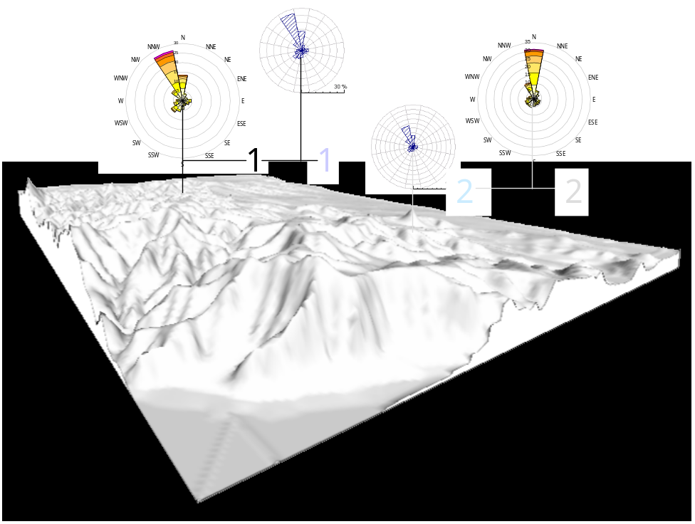

Figure 2 Self and Cross-checking procedure: Correlated measurements against model estimations

The reference mast #1 data (large rose) is used as input to run WAsP and estimate the wind climate at the location of mast #2 (small rose). Since there we have an equivalent climatology, estimations can be compared against actual measures.

Such comparison is made in terms of a wind turbine production since we have experienced that small discrepancies in terms of wind speed may hide significant differences in AEP. The “measured” production is computed by the raw product of the correlated wind distribution (no Weibull fit) times the power curve.

Discrepancies between these two magnitudes of the order of 25% are commonplace for masts located few hundreds of meters apart each other on moderately complex terrain. Much larger values have also occasionally been detected in rougher scenarios. Note that directional shifts are not considered in this kind of comparison although they may be important when considering wake loses calculations afterwards.

Moreover, in the following examples, the above-mentioned cross-check is made at the same (measurement) level at the reference and the auxiliary masts in an attempt to split the errors in the horizontal and the vertical extrapolation performed by the model and focus only on the first ones although our everyday experience indicates that model discrepancies due to the vertical extrapolation may be even bigger than those due to the horizontal one (6) specially for the tall megawatt turbines.

The later is normally true at the reference point when comparing different measurements levels among them. Moreover, if there is only a measurement level what we call self-check error arises. Discrepancies of the order of 5% and even bigger between measurements and model results at exactly the same point have occasionally been detected. The source of these self-check errors is not clear, some may be due to a improper Weibull fitting or to the differences between “emergent” and “combined-Weibull” distribution (7) while in other cases the cause remains unknown. In any case this discrepancy must be retained and corrected later in the wind farm design calculations. Again we, perform this correction in terms of AEP.

Inverse-of-the-Distance Weighted Combination

To make use of all the available information from the deployed masts a combining procedure has been developed. It is represented in figure 3
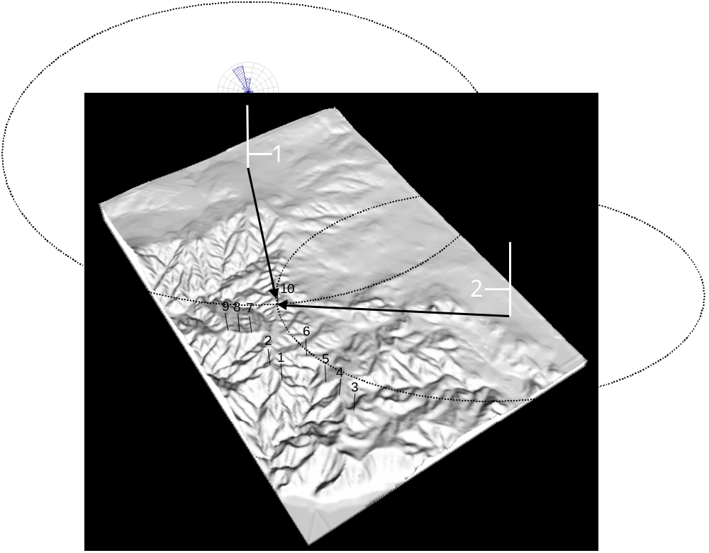

Figure 3 Inverse-of-the-distance weighted combination of modelling results
Considering that all measurements are equally valid, at least at their respective measurement point and height, a combination of modelling results using each set of correlated data as input is performed.

Nevertheless, measures at some points may be more representative than others when speaking about horizontal extension. Thus, the applied combination of results is weighted not only by the natural inverse-of-the-distance factor but modulated taking also into account terrain (slope) similarities and the previous cross-checking results, among other factors. This adjust is very case-specific and it is difficult to establish general rules for it. Attempts to objectively relate terrain-complexity indexes (like well-known Risoe’s RIX) with the cross or even self-checking errors had been proved unsuccessful due to a too-large scatter of the results.

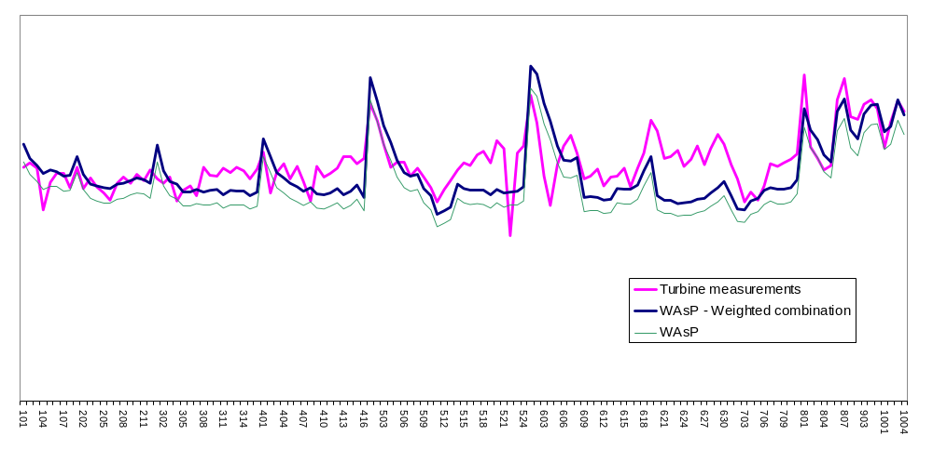
In any case, the combination of model results has the propriety of being at least true at all the measurement masts locations. Nevertheless, the real benefit of this procedure is that it has also proved to reduce the errors at the turbine locations as shown in project #192, where 113 Ecotècnia turbines were actually installed and operated for several months (fig 4). In this example the improvement of using all the masts instead of the reference one only is of the order of the 6% again in terms of AEP.

Figure 4 Comparison of plain WAsP and weighted combination technique against actual turbine measurements. Project #192, November 2002.

CFD

But, of course, comparing model procedures against actual turbine measurements is a too-late checking and in Ecotècnia we have traditionally maintained an active effort on the search of more accurate methods of flow solving over complex terrain. Since 1999 when a collaboration with the University of Girona (Spain) was performed, one of this research fields is CFD.

CFD (Computational Fluid Dynamics) is based on the numerical soltion of the primitive (non linearized) Navier-Stokes equations. The lack of linearization does not mean that the equations are not simplified (a certain degree of approximation is always necessary) but implies that the non-linear terms are retained. These terms are the responsible, for example, of the recirculation of the wind that makes the lee-side of mountains less windy than the upwind ones (effect that is neglected by linear models) but they influence also wind at the top of the ridges or hills. Additional advantages of solving the complete set is the possibility of obtaining results of 3D fields of the vertical wind component or the turbulent kinetic energy among other variables.

CFD technique’s beginnings can be placed in the late 70s but its application was during many years restricted to closed flows (pipes, engines) only. Due to the late increasing computational power the equation solvers (there are several in the market) have recently been applied to open flows too.

VECTOR AS’s WindSim package (8) is based on the 3D Reynolds-Averaged Navier-Stokes solver PHOENICS (the most veteran of them) for the the non-linear transport equations of mass, momentum and energy. The input basis for WindSim consists of a digital terrain model on a proper length scale from detailed micro siting up to larger meso scale. WindSim uses so called body fitted co-ordinates (BFC) with refinement towards the ground. Its runs begin with a logarithmic wind profile as a lateral boundary conditions but its power lays in the possibility of perform nested runs with increasingly detailed resolution (from 100m to 10m have been done in the presented examples) where inner boundary conditions are taken from larger run results.

The collaboration between Ecotècnia and VECTOR has had several phases, since a first blind test in 2000, until the beta-testing of the Windows version of the software since the end of 2002.

Results

Due to the limited time of test of the models, only some preliminary results are shown in the present work.

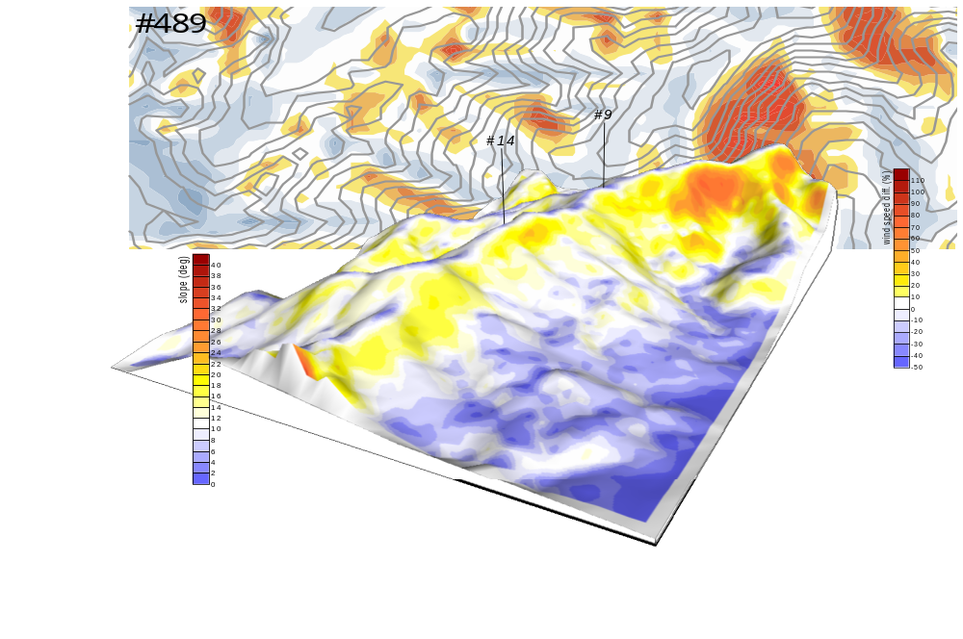
Figure 5 Project #489. Slope of the terrain, location of masts and WAsP-WindSim differences

First example is project #489 (figure ) where, on a ridge approximately perpendicular to the westerly winds, masts: #14 (reference) and #9 are cross-compared. Surrounding terrain is quite complex in terms of terrain slopes (up to 40deg) and the bigger differences between WAsP and WindSim are obviously found at the lee side. In any case, although both masts are on the top of the ridge, their cross-checking results are quite different, in terms of a Ecotècnia 74 (1.67MW) AEP, when WAsP (28.1%) and WindSim (19.1%) are applied.

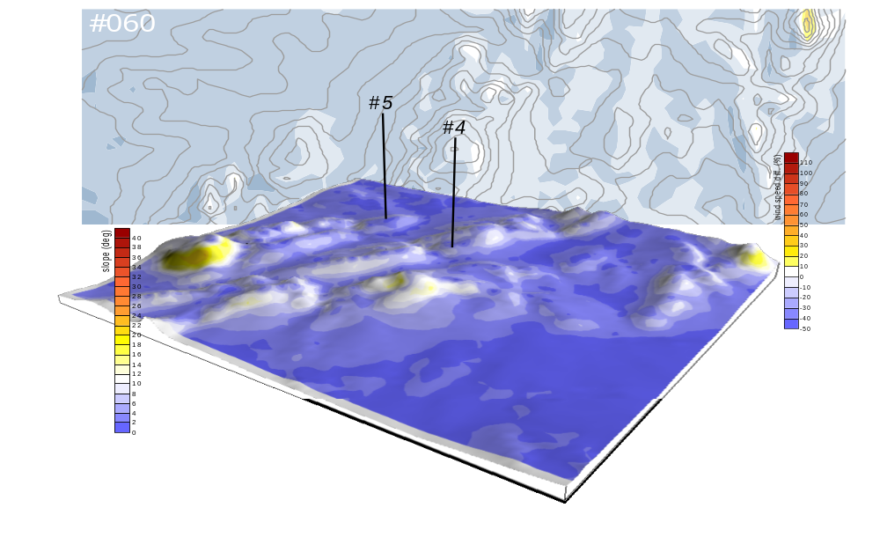
Figure 6 Project #060. Slope of the terrain, location of masts and WAsP-WindSim differences.

On the contrary, in project #060 such difference (14.5% vs. 14.2%) is not so big probably due to the less steepness of the terrain. The quite large absolute error of both models (compared with measurements) is probably related with a wrong roughness assignment of the terrain.

Conclusions

Summarizing:
- Even for moderately complex terrain, discrepancies between linear models and reality can invalidate wind resource studies.
- Cross (and even Self) check of model results and measures in terms of AEP is a need when talking about complex terrain
- An elevated number of measurement points can help to reduce the errors if a weighted combination of model results is performed (tested against actual turbines production). Suitable MCP techniques allow for a saving in the cost of such campaign.
- Such checking gives increasingly different results for WAsP and WindSim according to the complexity of the terrain for the limited tests performed
- For steep terrain, WindSim shows a better agreement with mast measurements in the studied examples

Bibliography

(1) http://www.nve.no/vindatlas

(2) Prats P. New Wind Turbine Concept in the MW Range. Proceedings of the Global Wind Power Conference & Exhibition. Paris (F) 2002

(3) Woods J. An Independent Review of Ecotecnia’s Wind Resource Assessment Methodology. Energy Research Unit of Rutterford Appleton Laboratory. Oxon (UK) 1997.

(4) An improved MCP algorith for the prediction of the long term wind climate in regions of complex environment. JOR3-CT98-0295. EU 1998-2000.

(5) Troen I. & Petersen E.L.. European Wind Atlas. ISBN 87-550-1482-8. Risø National Laboratory. Roskilde (DK) 1989.

(6) Moreno P. et al. Vertical Profile of Wind. Comparison of 3 SODARs and a 100,-high Meteorological Mast. Proceedings of the European Wind Energy Conference & Exhibition. Madrid (E) 2003.

(7) http://www.wasp.dk/menu_support/TechNews/WindDistributions.html

(8) http://www.windsim.com

